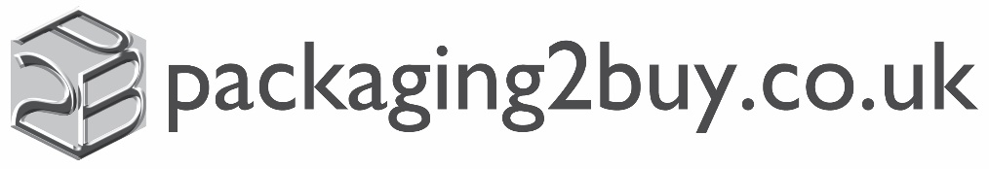

20th May 2020

Bunzl Retail and Healthcare Limited is committed to the health, safety and welfare of its employees as its first priority. A risk assessment has been conducted in accordance with Government guidance on working safely during COVID-19, which was issued on 11th May 2020.

The risk assessment has been used to identify potential risks related to exposure to, catching and spreading COVID-19 and has identified the measures needed to reduce risk to the lowest reasonably practicable level by taking preventative measures, in order of priority. The risk assessment recommendations have been shared with our employees.

Measures in Use to Reduce Risk:

- Increasing the frequency of handwashing and surface cleaning in the workplace
- Enabling our employees to work from home where possible
- Taking all reasonable steps to maintain a 2 metre distance in the workplace
- Keeping the activity time involved in tasks as short as possible
- Using back-to-back or side-to-side working (rather than face-to-face) whenever possible
- Reducing the number of people each person has contact with by using ‘fixed teams or partnering’ (so each person works with only a few others)
- Finally, where people must work face-to-face for a sustained period with more than a small group of fixed partners, then we have assessed whether the activity can safely go ahead. In such circumstances, where required, additional Personal Protective Equipment, for instance face coverings have been made available

Particular regard has been given to employees who are especially vulnerable to COVID-19 and appropriate measures have been taken to minimize their personal risk, including home working and reassignment to tasks and activities that reduce that personal risk to the lowest reasonably practical level.

Particular regard has also been given to understanding the circumstances of those with protected characteristics and any measures or adjustments that may been needed to address a different degree of risk or alternative measures that may be required under the Equality Act 2010.

The Government guidance related specifically to working safely in Warehouses, Offices & Contact Centres, Vehicles and Retail Branches has been incorporated into the risk assessment.

Furthermore, the risk assessment has taken account of Government guidance on travelling to and from work, meetings in the workplace and the presence of visitors and contractors at Bunzl locations.

The risk assessment that has been carried out will be kept under review and revisited periodically, or where Government guidance is amended or updated.

